**MLST Typer**

**General Comments**

Multilocus sequence typing (MLST) protocol was designed to overcome the low discriminatory power and poor reproducibility of older molecular typing schemes, and is useful for inter-laboratory, inter-regional, and inter-national comparison of the pathogenic clones. However, MLST includes labor-intensive sequencing processes and meticulous allelic / ST determination processes, often prone to errors. “MLST typer” is a free, automated program based on Visual Basic for Applications (VBA) macro, which runs through Microsoft Excel.

**Instructions for Use**

**Main page**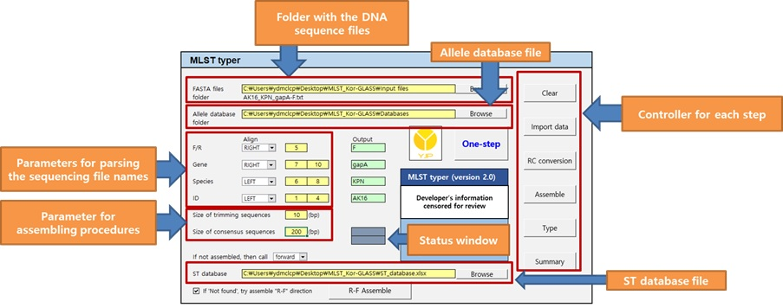

1. Determining folder location for sequencing data.
2. Determining folder location for allelic database.
3. Input parsing parameters of sequencing file names containing information about the forward or reverse direction, gene names, species names, and identifiers. Parsing information can be designated in order from either left or right, and the parsed examples are shown on the mint-colored sections.
4. The designated species and gene names from sequencing files should be correlated with the allelic DB names and their worksheets’ names, respectively.
5. Non-alphabetical / non-numeral values in parsing information are automatically omitted.
6. Input the size of trimming and consensus sequences for the assembling procedure.
7. User may also choose alternative action to take when assembly is not possible: take either forward strand or RC converted reverse strand for allelic determination, or just terminate the further processing for that set.
8. Determining file location for sequence database.
9. Buttons on the right side of the console stand for executable processes arranged from top to bottom in order of workflow. ‘One-step’ button will perform all processes at once.

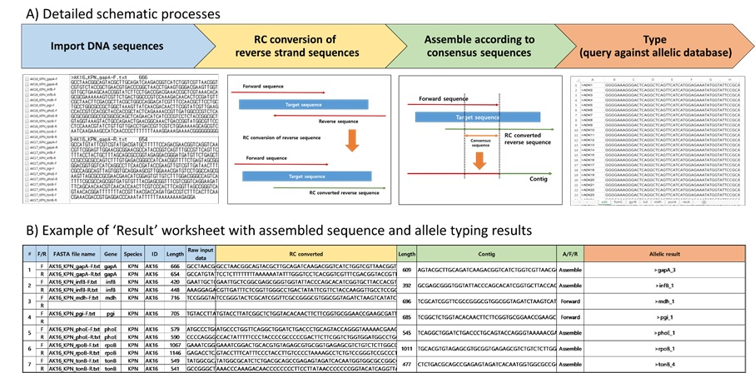**Result page**

1. Parameters provided by the user is specified on the top of the ‘Result’ page shaded in gray.
2. Color coded columns represent the generated results from each process as follows; blue for ‘Import data’, yellow for ‘RC conversion’, green for ‘Assemble’, and red for ‘Type’.
3. The blue columns contain parsed information designated in the console.
4. The imported and RC converted sequences are exhibited in yellow columns.
5. The ‘Contig’ column in green contains the sequences for further processing, and that sequence can be either assembled, forward, or RC converted reverse sequence.
6. On the ‘Allelic result’ column in red, the determination results of each gene’s allelic type are given, and “Not found” is seen when the processed sequence is not found in the allelic database.
7. “Export” button will save a copy in a new Excel workbook.

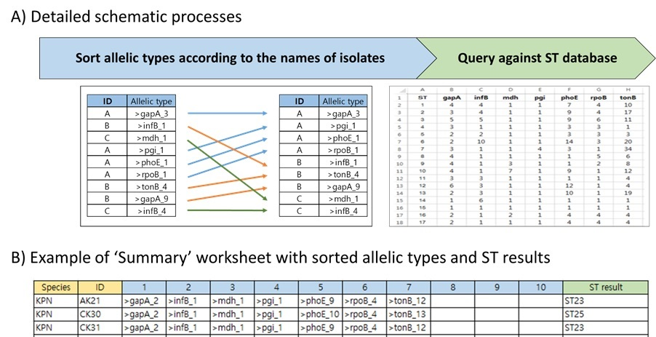**Summary page**

1. This page aligns allelic types according to their isolate names.
2. Species information and isolate name is given along with the allelic numbers of each housekeeping gene.
3. For ST determination, isolates with complete allelic profiles are queried against the ST DB. If the matching allelic profile is found in the ST DB, corresponding ST is given in the ‘ST result’ column.
4. Alternative messages are given in following conditions; “Possible new ST” for the complete allelic profile not matched in the ST DB, and “Not full set” for an incomplete allelic profile.
5. “Export” button will save a copy in a new Excel workbook.

**Miscellaneous**

In some cases, the longest contig can be generated by assembling the RC converted reverse sequence before the forward sequence. Therefore after “Type” function has been completed, unidentified sequences can be solved by “R-F Assemble” function, which makes a contig in reverse-forward-assembly order, followed by “Type” and “Summary” processes. “R-F Assemble” processed sequences are highlighted by yellow cell color in the ‘Allelic result’ column of the ‘Result’ page. User also can decide to include this function in “One-step” procedure by checking the control box.

**Contact Information**

Developed by Yu Jin Park, Min Hyuk Choi, Dokyun Kim, Kwangjun Lee, Hyun Ok Kim, and Seok Hoon Jeong

Yu Jin Park: [parkyj@yuhs.ac](mailto:parkyj@yuhs.ac)  
Dokyun Kim: [kyunsky@yuhs.ac](mailto:kyunsky@yuhs.ac)

Department of Laboratory Medicine, Research Institute of Bacterial Resistance,  
Gangnam Severance Hospital, Yonsei University College of Medicine,   
211 Eonju-ro, Gangnam-gu, Seoul 06273, Korea  
Tel: +82-2-2019-3532, Fax: +82-2-2057-8926